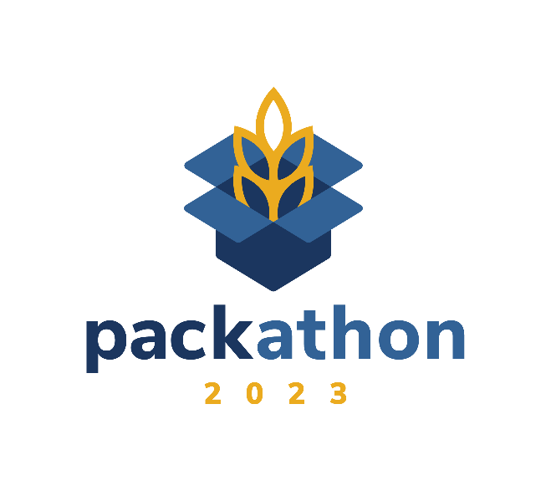

WHAT IS PACKATHON?
Packathon aims to foster community involvement as we work together to end hunger today, tomorrow, and for good! The annual, signature, hands-on food-packing event for the Great Plains Food Bank provides help and assistance to our community members in North Dakota and Clay County, Minnesota who are food insecure. The first Packathon took place in 2013. For more information contact Rebecca Knutson at rknutson@greatplainsfoodbank.org.

WHEN AND WHERE DOES PACKATHON TAKE PLACE?
Packathon is held at the two warehouse locations of the Great Plains Food Bank.
Fargo: April 24 and 25
Great Plains Food Bank, Statewide Distribution Center
1720 3rd Ave. N
Thank you to our Premier Partner, Merrill Lynch, and our Contributing Partner, Bell Insurance.

Bismarck: April 27 and 28
Great Plains Food Bank, Regional Service Center
1315 S 20th St.
Thank you to our Premier Partner, Basin Electric Power Cooperative.

HOW IS THE EVENT STRUCTURED? WHO PARTICIPATES?
Local and statewide businesses in Fargo and Bismarck, who have joined with us in our mission to end hunger together, are invited to form a team of ten employees ten (with room for up to 15) to participate in this exclusive food-packing and awareness-building experience. Only 20, 1.5-hour, volunteer shifts are available (10 in Fargo, 10 in Bismarck), with five teams scheduled each day, over the span of the four-day event. Shifts run 7 a.m.-6 p.m. Groups reserve their preferred time slot, knowing they fill on a first-come basis.
Each participating group donates $1,500 to support the cost to “move the food” they pack at either the Fargo or Bismarck warehouse. The donations are used to support the costs of trucking the surplus food such as gas, vehicle maintenance, and distribution.
Great Plains Food Bank celebrates and highlights each team’s impact during a welcome orientation before their scheduled packing time and a closing reception, with refreshments and opportunities for further engagement.

WHY ARE FUNDS NEEDED TO HELP “MOVE THE FOOD?”
The Great Plains Food Bank partners with 193 food pantries, shelters, and soup kitchens in 100 communities across North Dakota and Clay County, Minnesota, providing 9.9 million meals to 138,439 individuals in need annually.
Eighty percent of food distributed by our network of food pantries comes from the Great Plains Food Bank. Our goal for Packathon 2023 is to engage 20 teams to pack 50,000 pounds of food and raise $50,000, which supports our costs to provide service to our partner agencies and source and distribute the surplus food packed to thousands of individuals across our service area.
Ninety-five percent of Great Plains Food Bank revenue is used to deliver programs and services to people facing hunger.

ARE THERE OTHER WAYS TO HELP?
Yes! The Impact Menu provides opportunities for individual Packathon team members, or businesses, to be involved at a deeper level in our work to end hunger today, tomorrow and for good. Whether participating on a Packathon team or unable to join, businesses are encouraged to share the Impact Menu with all staff. Items featured show how each financial donation can support the Great Plains Food Bank’s ability to source and distribute food to targeted populations needing assistance due to barriers/access challenges. Through donation “add-ons,” individuals or teams can deepen their impact and help the Great Plains Food Bank get food and services closer to the people who need it. This can be done prior to, or as a follow-up to Packathon.
Donation “add-ons” help fill the gap by supporting the following programs and services of the Great Plains Food Bank:
- School Pantry
- Food Distribution
- Senior Food Pack
- Wellness Pantry
- Meal Delivery
- Diaper Bank
- BackPack Program
- Mobile Food Pantry

WE WOULD LIKE TO PARTICIPATE. WHAT IS NEXT?
It is easy! Spots are limited. The first step is to register.
- Register by March 31 at https://give.greatplainsfoodbank.org/pack2023.
- Select your preferred date and volunteer time. Teams are scheduled on a first come, first serve basis, so requests are not guaranteed but we will do our best to accommodate. As a reminder, Packathon is April 24 and 25 in Fargo and April 27 and 28 in Bismarck. Please double check to make sure you register for the correct date based on your location.
- You will be required to provide contact information for a team captain. All information from Great Plains Food Bank regarding Packathon will go to this person.
- When Great Plains Food Bank receives your registration, you will receive an automated confirmation of your registration.
- The team captain is responsible for forming the team of ten (with room for up to 15) that will represent your company at Packathon. Great Plains Food Bank will be in contact with your team captain to provide a checklist of next steps, collect team member information, and communicate day-of expectations.
- Questions? Please contact Rebecca Knutson at rknutson@greatplainsfoodbank.org.

