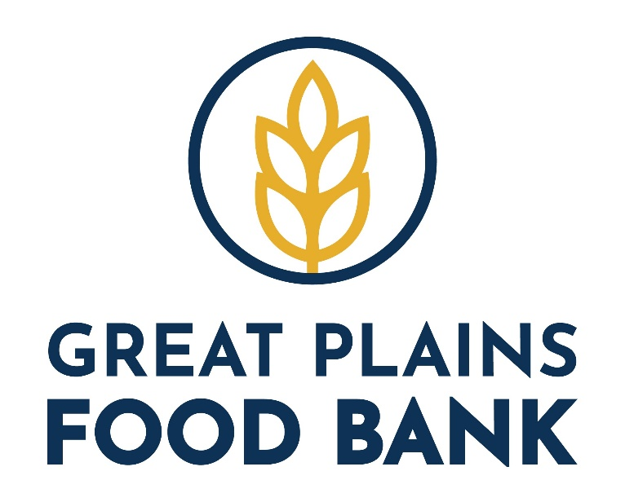 | Retail Food Rescue  Manual

1720 3rd Ave N - Fargo, ND 58102 - p) 701.232.6219 - f) 701.232.3871
1720 3rd Ave. N – Bismarck, ND 58504
greatplainsfoodbank.org
Updated 6/2022

Table of Contents

Welcome to Retail Food Rescue 3

Partner Requirements
Partner Introduction 4
Identify Agency Capacity 5
Partner/Food Bank Role 6
Distribution of Food donations 7
Secondary Distribution Records 8
Partner Agreement 9-10
Receipts
Receipting Process 11
Example Receipt 12
Equipment
Equipment Needed 13
How to calibrate a thermometer 14
Calibration Records 15
Training 16
Product – What to expect
Meat Department 17
Seafood Department 17
Produce Department 17
Deli Department 17
Dairy Department 18
Bakery Department 18
Donated food temperature Guidelines 19
Donation Standards 20
Donation Handling and Storage Guidelines 21-23
Allergen Control 24

USDA Safe Handling Guidelines for Meat, Poultry and Fish Donations 25
Feed Back Form 26
Frequently Asked Questions 27
Glossary of terms 28

WELCOME TO RETAIL FOOD RESCUE
BASIC PROCESS:
The retail store sets aside the product to be donated at the end of each business day/cycle. The Partner picks up the product at each of the retail store locations at a predetermined day and time. The product is to be transported and stored properly; using the temperature controlled equipment, and brought back to the Partner location for inspection, receipting, and distribution to clients.

Our retail Food Rescue program connects our partner agencies with local retail grocery stores to rescue closed-dated, mislabeled, perishable, surplus or distressed food product. This rescued food is then on the dinner tables of hungry neighbors within days.

History:
Feeding America members started partnering with retail grocery chains in 1990 to recover products that were identified as not marketable but still usable and safe
Great Plains Food Bank Started the food recovery program in the Fargo/Moorhead area in 1992

Dear Partner,

Thank you for partnering with Great Plains Food Bank and our Food Industry Partners to pick up donations from a local retailer! Because of your partnership, proximity to the retailer, and high food safety standards we are pleased to offer these products to you.

The Great Plains Food Bank is proud to partner with National and Local Retail Food Industry Partners. Together we are working to eliminate the nearly 27% of all food produced in the United States that never makes it to the dinner table. At the same time thousands of children, seniors and working parents across North Dakota and western Minnesota are living with, or at immediate risk, of hunger. Our role at the Great Plains Food Bank, with your help, is to get this surplus food from those who have it, to those who need it.

Retail donations are the largest donation stream of food for the network. Thanks to the hard work and commitment of our product donation partners and people like you, retail recovery has come a long way since pilot programs began expanding in the early 2000s. ​​​​​​In fiscal year 2021, for the first time ever, Nationwide, WE secured more than 2 BILLION pounds of food through retail donations. But we are just getting started. There is tremendous potential to grow retail recovery and source even more nutritious food.​
​​​​​​​​​​​​​​​​​​​​​Donations from retailers (grocery, c-store, restaurants) and wholesalers provide members with the opportunity to access a wide variety of product, including a large volume of nutritious food.

Should you have any concerns, questions or challenges, please feel free to contact us. We’ll serve as your representatives and will do everything we can to assist you.

Janelle Brandon
Programs Director
701-371-0798
jbrandon@greatplainsfoodbank.org

Kayla Beck
Regional Services Manager (West)
Direct: 701-390-2513
kbeck@greatplainsfoodbank.org

Stephanie Erickson
Food Resource Manager
Direct: 763-913-6433
serickson@greatplainsfoodbank.org

Identify agency capacity

- Identify the number of days and hours the agency is open and distributing to clients. The frequency of pickups should influence the agency’s days and hours of operation.
- The number of households or people served by the agency on a weekly or monthly basis.
- The agency must be in good standing and have passed their most recent food bank audit.
- The proximity of the agency to the store or stores (must be within a 30 minute drive from store to agency).
- The agency’s ability to pick up from a store at least once a week. Best practices may require pickup of at least three times a week
- The agency must pass food safety training before the first retail pickup. The agency must keep that certification current, and must participate in an annual or yearly food safety training which many food banks host at their location. (Serv safe Trainings )

- The agency must have adequate cooler and freezer space.
- The agency must have ambient or dry storage space.
- The agency is evaluated based upon their access to vehicles or their fleet size.

- Will the vehicle or vehicles support the pounds available at each retail pickup?
- Is there adequate space in the vehicle to keep the integrity of the product intact (dry, refrigerated, and/or frozen)?
- Are the vehicles clean and reliable?
- The agency must have an active volunteer base or staff. The agency’s retail representative must be identified and assigned to a store prior to store donation program training and the first pickup.

- The agency must commit to picking up everything from the store. Cherry picking is not permitted, and this activity may be cause for dismissal from the retail store donation program.

PARTNER REQUIREMENTS

Partners picking up refrigerated or frozen items such as meat, produce, dairy and deli are required to refrigerate these products during transportation and storage. Partner are required to adhere to the donation handling and storage guidelines. Approved transportation devices can include temperature controlled coolers, thermal blankets or refrigerated trucks. One representative from the Partner is required to complete the “ServSafe Food Handler Guide for Food Banking” training, take and pass the quiz, and receive the certificate of completion. It is recommended that one person per Partner complete the full ServSafe training and certification.

PARTNER CONTRACT:
Annually, Partners will be asked to sign a contract for the calendar year adhering to the food safety, transportation and proper handling guidelines

Partner’s role and responsibilities are:
- Pick up product at the designated time
- Perform visual inspection of product, take temperatures at the retail store and again at the Partner
- Provide proper transportation and storage, including use of temperature controlled equipment
- Receipt the product categories and weights to the Great Plains Food Bank on a weekly basis
- Report any volunteer or personnel changes to Great Plains Food Bank within 1 week
- Share any issues or concerns with GPFB as soon as possible
- Updated holiday schedules and any possible skips in pickup dates

FOOD BANK ROLE:
The Great Plains Food Bank’s role and responsibilities are:

- Assign certified Partners to pick up at retail store(s)
- Train and monitor the Partner
- Provide necessary equipment for proper temperature controlled transportation/storage
- Ensure pick up drivers have proper food safety certification/training
- Manage the relationship with the donor/retailer
- Receive the receipts from the Partner and forward to Feeding America
- Address any Partner or retail store issues or concerns

DISTRIBUTION OF FOOD DONATIONS:

If a Partner receives excess product from Retail Store Donations, they are ONLY allowed to share that product with other GPFB Partner. To meet the requirements and/or requests of food donors, GPFB must ensure that the product donations are being properly handled, stored and distributed in an appropriate manner. GPFB Partners are held to the necessary standards, by Site Visits and reporting requirements.

A list of GPFB Partners can be found at greatplainsfoodbank.org under the “Get Help” section. A Partner can only share product with Partners on this list that do not have an * by them. If you do not see a Partner on the list that you currently share with, please contact your Regional Services Manager so that we may approach them about partnership.

When sharing excess retail product with another Partner, food safety guidelines must be followed. Partner must track the pounds and temperatures of any shared products. Please keep a record including: Name of Partner receiving excess product, date shared, pounds shared, temperature at delivery/pick-up and a brief description of product shared. See PARC.

Secondary Distribution Record
If your agency is sharing product picked up at participating retail locations the following must be documented.
1. Agency that picked up the product
2. Agency that is receiving the product
3. Weight of the shared product
4. Description of the product
5. The temperature of the product given
6. Temperature of product received

Primary Agency | Secondary Agency | Weight of product | Description of product | Temperature of product Given | Temperature of product received

PARTNER AGREEMENT
Partner Name:
City: State: Zip:
Primary Phone Number: Fax Number: __________________________________

Partner Contacts:
Primary Contact:
Name: ___ ________________________ Phone Number: __
Email: ______________________________________ Preferred form of contact: Email / Phone
Secondary Contact:
Name: ______________________________________ Phone Number: _________________________
Email: ______________________________________ Preferred form of contact: Email / Phone
Food Rescue Program:
GPFB Driver Pick-up ___
Volunteer Driver Pick-up ______
Partner Agency/Enabled Pick-up _____
Partner Contact at Pick-up:_______________________________
Phone #: _______________________________

_____ Partner delivered donations to receiving dock (Partner employee picks up and brings all items to driver)
_____ Driver enabled department pick-up (driver goes to each department and checks designated areas themselves for donations)
_____ Driver Assisted Department Pick-up (driver goes to each department and asks department lead for donations)
Participating Departments:
___ Bakery ______ Dry Grocery/non- food
_____ Dairy _____ Meat
___ Deli _____ Produce

Agreement:
Program Notes: (Some stores have specific pick up notes of how they like it done and where to pick up)
_________________________________________________________________________________________
_________________________________________________________________________________________
_________________________________________________________________________________________
_________________________________________________________________________________________
_________________________________________________________________________________________

- The agreed upon days and times that GPFB/Agency Partner will pick up food are:

If GPFB/Agency Partner is unable to pick up at this day/time, they are to contact the store directly and notify Food Resource Manger
- GPFB/Agency Partner are required to check and maintain safe temperature ranges for all items during transport. Thermal blankets, cooler bags and temperature guns will be made available to partner agencies upon start up. GPFB drivers will drive refrigerated trucks maintained at 41 degrees at all times.
- GPFB/Agency Partner agree to follow any specific donation pick-up guidelines as outlined above by Food Industry Partner.
- Food Industry Partner agrees to follow safe handling of donate product by following department guidelines provided in training. This includes:
- placing donated items in boxes in designated donation area
- keeping food at required temps and not removing from cooler/freezer prior to donation
- no mold/decay/rot/bugs on donated food
- Food Industry Partner should notify Food Resource Manager immediately with any questions or concerns regarding donation program.
- Food Industry Partner will notify GPFB with any contact changes
- GPFB Food Resource Manager will follow through with 2 scheduled (more as needed) visits per year for necessary training and program updating or as needed and agreed upon between both partners.
- GPFB will provide Food Industry Partner with timely receipts for donated product.

Food Industry Partner Representative: Date:

GPFB Representative: Date:

Receipts

The receipts associated with the retail store pickups are vital to the success of this partnership. Each week the GPFB must report national donor donations to Feeding America, who then passes the receipts onto the national retail store partner. If a receipt is missing we (GPFB/Feeding America/Partner) are out of compliance with our agreement to the national retail store partner and jeopardize the continuation of these donations. The same applies to local donor receipting processes.

RECEIPTING PROCESS:
A sample copy of the receipt is on page 18, but your Regional Services Manager will give you a personalized copy for use. If you need changes made or additional receipts, please contact your Regional Services Manager.
- Before picking up
  - Be sure the top portion is appropriately filled out with your partner agency name, date, retailer name, etc.
- At the store
  - Perform a visual inspection of the food items checking for insect/rodent activity, odors, cleanliness, contamination, damage or exposure
  - Take the temperatures of the frozen, refrigerated and dry goods, ensuring it is within the proper temperature range
- At your agency
  - Take the temperatures of the frozen, refrigerated or dry goods again and record, ensuring they are still within proper range after transportation
  - Weigh and record within each category of food items
  - Verify the receipt is fully filled out and entered into PWW by end of day FRIDAY or SATURDAY if that is your last pick up of the week.
- If you do not pick up for any reason you must still enter a receipt into PWW with the date you were supposed to pick up and then choose a reason for not picking up from the drop down box.

LATE RECEIPTS:
If GPFB has not received your receipts by the end of the following week, you will be contacted and asked to turn them in immediately. If receipts are not up to date after 45 days, GPFB reserves the right place the Partner on Suspension and to find another partner agency to take over the pickups and receive the donations.

Late receipts are not only noticed by GPFB, but by Feeding America and the national donor. If late or missing receipts are a continual problem, we risk losing the partnership with that retailer.
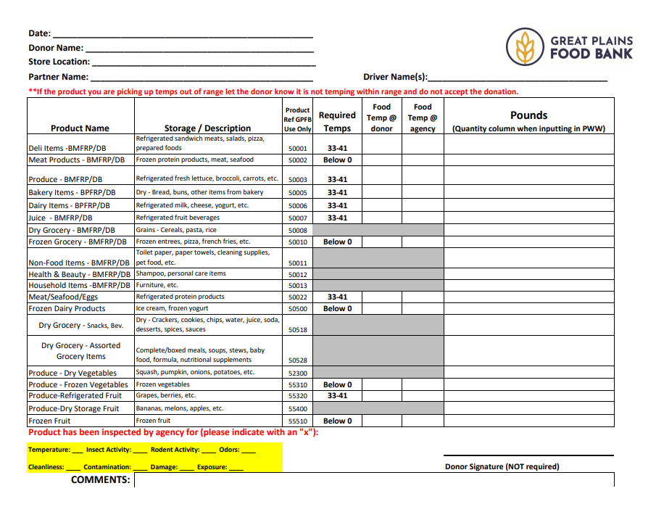
Receipt Example:

EQUIPMENT:
The Partner will be provided with:

- Freezer blankets/cooler bags/tarps
- Infrared thermometer
- Checks the surface Temperature
- Cannot be calibrated- check for accuracy
- Long stem thermometer
- Checks the internal Temperature
- Should be calibrated bi-monthly
- Scale
- Temperature logs
- Donation receipts

Should the Partner need replacement or additional equipment, they should notify their Regional Services Manager. A fee may apply.

How to calibrate a thermometer:

Stem Thermometers:
- Completely fill a Styrofoam cup with ice.
- Add clean tap water just to the top of the ice and let it sit for 4 minutes to allow the temperature to stabilize. The temperature of ice will stabilize at 32 degrees F.
- Put the thermometer probe into the ice water at least up to the dimple on the side of the probe. Don’t let the probe touch the bottom or sides of the cup. Hold it in place for 30 seconds or until the temperature indicator stops moving. If it is accurate it will read 32 degrees F. If it doesn’t read 32 degrees F, follow the instructions below.
- With the probes still in the ice water, hold the calibration nut (hex nut) under the dial head with a wrench or pliers. Rotate the dial head with your fingers (if it is loose enough) or another pair of pliers until the dial reads 32 degrees.
- Recheck after calibration to make sure the dial stays at 32 degrees.
** Hint: Remember that each line represents 2 degrees and it is easier to see the exact location of the needle if you close one eye.
Laser Thermometer:
- Completely fill a Styrofoam or insulated cup with ice.
- Add clean tap water just to the top of the ice and let sit for 2 to 4 minutes to allow the temperature to stabilize. The temperature of ice will stabilize at 32 degrees.
- Point the laser gun at the cup of water and take a temperature reading. If the temperature does not read 32 degrees F, you may need to change your batteries.
- If you have checked the batteries and it is still not working correctly, you will most likely need a new thermometer. If you need a new thermometer, please contact your local Regional Services Manager.

When to Calibrate Your Thermometers
- Some thermometers cannot be calibrated but must be replaced, depending on the manufacturer’s directions. Example: Laser thermometers.
- If you are using a stem thermometer, it is a good idea to calibrate it each shift or when it gets bumped or dropped.

Long Stem Thermometer Calibration Record
Agency _____________________________
Date |  | Completed by

TRAINING:

Upon assignment of a Partner to a retailer, the Great Plains Food Bank staff will train/orientate the Partner.

Training outline:

- Schedule a meeting with the director/volunteer of the Partner and anyone responsible for the pick up or product.
- Review the annual agreement and gather signatures.
- Ensure that Partner personnel handling product has adequate food safety training. Certification of completion for the “ServSafe Food Handler Guide for Food Banking” is required for a minimum of one person per agency.

- Review the donation handling and storage guidelines.
- Review receipting and reporting procedures.
- Deliver equipment and train on proper usage and calibration of thermometers.
- Within the first 90 days of start-up, staff will schedule a follow-up phone call with the director/volunteer of the Partner to evaluate program operations.
- GPFB will conduct annual trainings for updates and new trainees.

Product – What to expect

Most store donation programs recover all or some product from the following departments. Below are details about what you can expect to find in each department.

MEAT DEPARTMENT:
The meat department usually includes random weight meats, prepackaged meats and hanging meats. At some grocery chains the meat department may include seafood and specialty (gourmet cuts) meats.
- Random Weight Meats: beef, chicken and pork packaged fresh either at a plant or in the store. This may also include prepackaged meat with a pre-determined weight such as tube-packed ground beef. Retailers with specialty meat departments may also include product wrapped in butcher paper. This product is only acceptable if a label is attached identifying the contents and the sell-by date. MUST be frozen to be accepted

- Hanging Meats (also known as hard pack): lunchmeats, prepackaged bacon, sausages, and hot dogs; and vacuumed packaged ham and turkey breast are the most common items in this category. Packages are also often hard plastic, which is where the term “hard pack” comes from. These products are generally part of the meat department and should not be confused with random weight meats that are more commonly found in the deli department. Does NOT need to be frozen to be accepted

- Frozen Meats: beef, chicken, pork and seafood that are shipped, stored and merchandised in a frozen state. These products may be ready to serve, may contain prep work such as breading or may have spices already added.

SEAFOOD DEPARTMENT: Seafood MUST be frozen to be accepted.
At some retail chains, seafood may be a department that stands alone. In most cases the meat department manager oversees the seafood department.
- Random weight fish and shellfish: packaged fresh either at a plant or in the store.

PRODUCE DEPARTMENT:
This department is pretty straight forward, fresh fruits & vegetables. Produce departments carry bulk and prepackaged product. Some produce departments will carry dried fruits and gourmet salad dressings as well.
- Product: slightly bruised, ripe and close dated fruits & vegetables

DELI DEPARTMENT: ALL Items must be labeled.
Deli departments tend to vary substantially. One retail chain may have extensive prepared food offerings and another may concentrate only on sliced-to-order meats and cheeses.
- Bulk Meats & Cheeses: product is sliced to order, which provides limited opportunity for donations. Close dated product is rarely available. Many delis have even learned to use end pieces in pre-made sandwiches or as ingredients in prepared meals. Delis that choose to donate ends should wrap and label the product.
- Prepared Meals: most retailers will avoid including prepared foods in their donation policies. However, some food banks are seeing pre-made sandwiches and fried/rotisserie chicken
- Prepackaged Deli Meats & Cheeses: prepackaged high grade cuts of meat & cheeses. The product is generally vacuum packed.
- Prepackaged Side Dishes: side dishes such as potato salad, pork & beans and salsas that have been prepackaged at a plant.

DAIRY DEPARTMENT:
There are two categories of products found in the dairy department. The first category consists of milk and milk byproducts that general come from a local, or company owned dairy. The second category is generally branded cooler products warehoused and distributed by the retailer.
- Dairy: milk and milk byproducts such as cottage cheese, whipping creams, half & half and eggs. These products generally come from a local or regional dairy and egg producing farm.
- Cooler: prepackaged cheeses, yogurts, juices, dips, egg substitutes and refrigerated bread and cookie dough. This product often is branded and covered by a reclamation policy. With the exception of yogurt and dips, most of this product will go through a reclamation process.

BAKERY DEPARTMENT:
Most bakery departments contain bakery items produced by the retailer and product delivered directly to the store by a vendor.
- Bakery: most dated pastries and private label breads. Most branded product, such as Master Bread, is DSD (direct store delivery). Vendors remove this product when it reaches the sell-by date and donate it from their warehouse or plant location.
- Self-Serve donuts can be donated in a cake box. The box MUST contain an ingredient/allergy label.
Donated Food: Temperature Guidelines
You are required to take the temperature of the food when you pick it up from the retailer and again when you bring the product back to your agency.
Refrigerated Food: 33°F - 41°F
Dry Storage Food: 41°F - 70°F
Frozen Food*: 0°F or below
*Frozen food should be stored at 0°F or below once you bring back to your agency.
If food is outside of the safe temperature zone, you must discard it!
Food Categories |  | Temperature Received
Refrigerated Milk & Dairy Products | 33-41°F
Refrigerated Meat, Pork, Poultry, Fish | 33-41°F
Refrigerated Fruits & Vegetables | 33-41°F
Non Refrigerated Fruits & Vegetables | 41-70°F
Frozen Food | Received @ 0°F or below; stored at 0°F or below
Eggs | Shell eggs 33-45°F

Refrigerated Fruits & Vegetables  33-41°F | Non Refrigerated Fruits & Vegetables  41-70°F | Non Refrigerated Fruits & Vegetables  41-70°F
Bagged Salad Mix | Apples | Apples
Broccoli | Bananas | Bananas
Carrots | Beans | Beans
Cut/Sliced Fruits | Berries | Berries
Cut/Sliced Vegetables | Corn | Corn
Leafy Greens (lettuce, kale, etc) | Cucumbers | Cucumbers
Mushrooms | Egg Plant | Egg Plant
 | Grapes | Grapes
 | Melons (honeydew, cantaloupe) | Melons (honeydew, cantaloupe)
 | Onions | Onions

*Exception: Sliced melons and cut tomatoes must be received at 41°F or lower
Thank you for complying with these food safety requirements. Proper food safety is imperative as we work together toward our common mission of creating hunger-free communities.
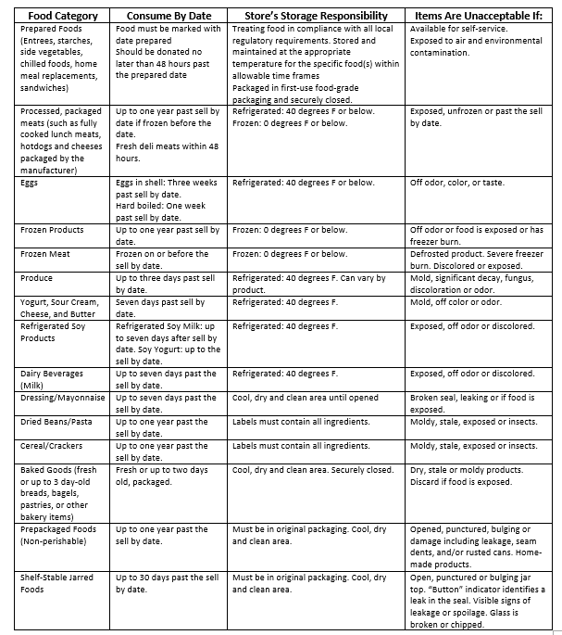

Storage and Handling Guidelines

Meat, Poultry, Fish
Condition
- Product should be in original packaging
- Food grade packaging in direct contact with food
- Securely closed and separated by food (beef, pork, poultry) to avoid cross contamination
- Labeled and dated as appropriate
- Frozen on or before the expiration date.
  - Fresh meat frozen: chops/steaks/roast 4-12 months
Ground meat 3-4 months
Poultry 12 months
  - Processed/Packaged meats up to one year past expiration date. Fresh deli meats within 48 hours of expiration
Handling & Storage
- Product should be frozen on or before the best by date
- Frozen product should be stored at 0° F or less while awaiting pick up. Under no circumstances can the refrigerated product be stored in excess of 41° F.
Non-Acceptable Conditions
- Food kept in the temperature danger zone for more than 2 hours
- Non-food grade packaging in direct contact with food
- Damaged or compromised packaging resulting in discoloration of product
- Defrosted product or product with severe freezer burn

Dairy Products
Condition
- Product should be in original packaging
- Food grade packaging in direct contact with food
- Up to 7 days past expiration (we ask for at earliest date to provide time for consumption)
- Eggs: three weeks past expiration
Handling & Storage
- Refrigerated product must be stored at 41° F or less while awaiting pick up
- If frozen, product should be stored at 0° or less while awaiting pick up. Under no circumstances can the product be stored in excess of 41° F.
- ONLY eggs are to be stored in egg crates. No other items
Non-Acceptable Conditions
- Damaged or compromised packaging resulting in the loss of sanitary barrier protection

Fresh Produce
Condition
- Product should be in original packaging and bags or food grade packaging (produce boxes) for all repacked product
- Cut produce should be securely closed in food grade packaging with each vegetable or fruit packaged separately.
- Can exceed expiration dates
Handling & Storage
- Store in a cool, dry, clean area
- Whole produce can be stored at room temperature
- Cut produce must be stored at 41° or less
Non-Acceptable Conditions
- Signs of decay

Baked Goods
Condition
- Fresh, day old bread, bagels and other bakery items
- Food grade packaging in direct contact with food, securely closed
- Bread product separately packaged from other baked goods
Handling & Storage
- Store in a cool, dry, clean area
Non-Acceptable Conditions
- Mold, damaged or compromised packaging resulting in loss of the sanitary barrier protection
- Product not in food grade packaging

Pre-packaged Foods – Non Perishable (Canned Goods)
Condition
- Fully intact original cans with labels that are legible; labels must show at minimum:
- what the product is b) ingredients c) net weight d) distributor
- Up to one year past expiration
Handling & Storage
- Store in a cool, dry, clean area
Non-Acceptable Conditions
- Opened, punctured, bulging, or serious damage to can, including evidence of leakage
- Home-canned products

Pre-packaged Foods – Non Perishable (Glass Jars & Plastic Bottles)
Condition
- Fully intact original cans with labels that are legible; labels must show at minimum:
- what the product is b) ingredients c) net weight d) distributor
- Up to 30 days past expiration
Handling & Storage
- Store in a cool, dry, clean area
Non-Acceptable Conditions
- Opened, punctured or bulging jar top
- Broken or chipped glass
- Home canned products
Pre-packaged Foods – Non Perishable (Boxes or Bags)
Condition
- Original boxes or cases
- Fully intact original containers with labels that are legible; labels must show at minimum:
- what the product is b) ingredients c) net weight d) distributor
Handling & Storage
- Store in a cool, dry, clean area
Non-Acceptable Conditions
- Opened, punctured, or damaged packaging resulting in loss of the sanitary barrier protection

Pre-packaged Non Foods
Condition
- Fully intact original containers with labels that are legible; labels must show at minimum:
- what the product is b) ingredients c) net weight d) distributor
Handling & Storage
- Store in a cool, dry, clean area
Non-Acceptable Conditions
- Glass that is broken or chipped

Note: Non-food items should be boxed separately from edible product.

Allergen Control
Products containing possible allergens must be stored and labeled appropriately. There are 8 main allergens to be mindful of:
- Peanuts
- Tree nuts
- Milk products
- Eggs
- Soybean products
- Wheat
- Fish and shellfish
Make sure the product is labeled clearly and packaged separately. Do not store a possible allergen on top of or too close to another food item. Ex. Do not place dairy products on top of ready to eat lettuce. If the dairy product were to spill it would contaminate the lettuce making it unusable. If there is a spill of a product containing an allergen clean the area immediately with disinfectant.

USDA Safe Handling Guidelines for Meat, Poultry
and Fish Donations

Feeding America, Food Banks and Partners participating in a retail store donation program to access donated meat and poultry products should be mindful of the USDA Federal Food Safety Inspection Service regulations governing the use of those products.

Donated meat and poultry products that do contain the USDA inspection certificate upon receipt (such as packaged raw chicken breasts, packaged ready-to-eat meat and poultry) may be frozen by the sell-by date and distributed in the following manner:
- Kept frozen and delivered to Partner for distribution to clients for cooking at home
- Thawed and cooked into meals by a production kitchen that serves meals on site (soup kitchens, shelters)
- Chilled or frozen for transport to an off-site food pantry for distribution to clients for home reheating

Donated raw meat and poultry products that do not contain the USDA inspection certificate upon receipt (ground beef processed in retail store, meat from butcher case) may be frozen by the sell-by date and distributed in the following manner:
- Kept frozen and delivered to Partner for distribution to clients for cooking at home
- Cooked into meals by a production kitchen that serves meals on site (soup kitchens, shelters)

Donated cooked meat and poultry products that do not contain the USDA inspection certificate upon receipt (rotisserie chicken, deli prepared meat) may be chilled or frozen and delivered to agencies for reheating and/or immediate consumption.

Donated raw or cooked meat and poultry products that do not contain the USDA inspection certificate upon receipt MAY NOT be processed/reprocessed in a central kitchen for distribution to an off-site meal program.

Example: Donated rotisserie chickens can be picked up at a local retailer and delivered to a congregate meal program for immediate consumption or chilled and reprocessed into a chicken casserole by a production kitchen for service in an on-site homeless shelter. However that product MAY NOT be reprocessed into a central kitchen for service to an off-site meal program.

Feedback Form

Date
Day of the Week: Monday Tuesday Wednesday Thursday Friday

Section 1: Donor Pickup

Donor name:
Donor Address:

- Donor not open when we pick up or drop off
- Donor regularly does not have food ready to pickup
- Donor often has no food to donate
- Donor is not donating specific departments
- Donor/ or agency requests a different pickup day
- Donor Representative is rude and difficult
- Donor is not practicing safe food handling
- Other
Section 2: Action wanting to be taken
Action to be taken

Stephanie Erickson
Food Resource Manager
serickson@greatplainsfoodbank.org
Direct: 763-913-6433

Kayla Beck
Regional Services Manager (West)
kbeck@greatplainsfoodbank.org
Direct: 701-390-2513
Janelle Brandon
Programs Director
jbrandon@greatplainsfoodbank.org
Direct: 701-371-0798

FREQUENTLY ASKED QUESTIONS

Q: If the temperature of the product is not in the safe zone, what do we do?

A: You should discover this at the store, and then you have 2 options. First, you could notify the store personnel and let them know and refuse the food. Or, take the food back to your agency and dispose of it there. Either way, please notify your Regional Services Manager, so we can talk to the retailer to ensure the food is being stored correctly. Make note under the comments section of the receipt as to amount of food disposed.

If the temperature was in range at the store, but during transport it changed, you will need to report that on your receipt and discard the product. It is NOT safe to distribute to clients.

Always be sure that your thermometer is calibrated. See PARC for calibration method.

Q: Why do I have to weigh the items separately in each category?

A: The GPFB tracks and records product based on categories (like fruit, vegetables, bakery, deli, etc.) to evaluate the nutritional value of the product, conduct analysis of whether retailers are giving equitably in each category and to accurately report back to Feeding America.

We also track frozen, refrigerated or dry products separately, because these products are all stored at different temperatures that need to be verified.

GLOSSARY OF TERMS

Best if used by date – product should be used by this date to experience the highest food quality (NOT AN EXPIRATION DATE)
Branded product – products produced and marketed to consumers under a given name, consumers come to expect a certain level of quality and integrity from items that are a part of the given brand name
Close dated – an expiration date that is displayed and legible to consumers
Cooler – refers to a category of products typically merchandised with or close to the dairy department

Dairy – a plant that produces milk and milk byproducts

DC – Distribution Center, a warehouse that distributes product to retail stores

DSD – Direct Store Delivery, product that is delivered directly to retail stores by the manufacturer, bypassing the retailer’s DC. Soda, chips and bread vendors are often DSD suppliers.

Expiration date – date at which a perishable product should no longer be consumed

Food Bank/GPFB – refers to the Great Plains Food Bank in this manual

Hanging Meats – prepackaged meats and cheeses that are vacuum-packed and merchandised on metal pegs in the meat or deli departments, may also be known as hard packs

Open dated – products that are either not dated or dated in a code only legible to those who can decipher the manufacturer’s coding system

Partner Agency Resource Center (PARC) - section of the GPFB website designed for partners that includes sample documents, recalls and other resources and information

Plant – Facility where food is manufactured. Could be a meat packing, frozen food, canned goods, baked goods, etc.

Partner – a food pantry, soup kitchen, shelter or meal provider that partners with the Great Plains Food Bank. Refers to your agency in this manual.

Random weight – refers to meat and cheeses that arrive at stores as large pieces and are cut/sliced to order (like in a deli)

Sell by date – the date a product should be sold by at the retailer

Shelf Stable – a product that can be stored and merchandised without the need for refrigeration

