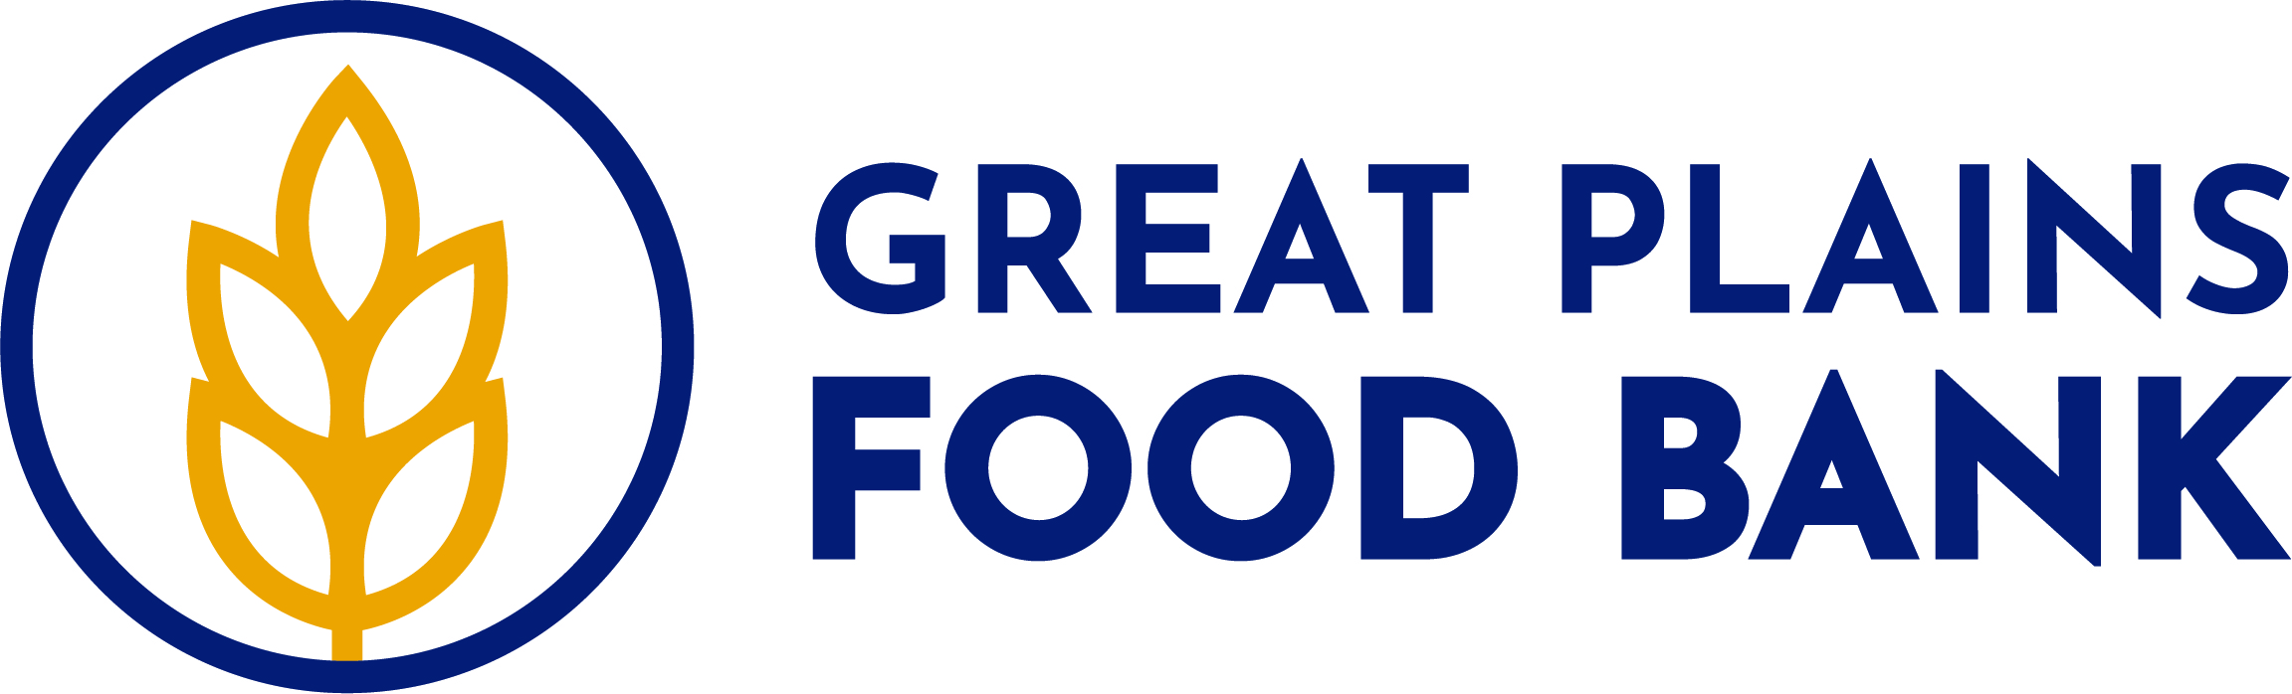
Great Plains Food Bank
ENDOWMENT FUND GIFT AGREEMENT

This Endowment Gift Agreement is made by and between _____________________________________ ["Donor"] and Great Plains Food Bank. The donor has delivered to Great Plains Food Bank the asset(s) described in the attached Schedule A, on the following terms and conditions:

- Pursuant to this Agreement, Donor has irrevocably transferred to Great Plains Food Bank the assets described in Schedule A attached hereto, receipt of which is hereby acknowledged by Great Plains Food Bank, subject, however, to all the terms and conditions set forth in this Agreement.

- The assets described in the attached Schedule A are given by Donor to Great Plains Food Bank to add to a permanent, irrevocable endowment fund the name of which is the Great Plains Food Bank Endowment Fund (the “Endowment Fund"). Consistent with the terms of the Endowment Fund Policy and applicable laws then in effect, Great Plains Food Bank may appropriate for expenditure or accumulate so much of the Endowment Fund as Great Plains Food Bank determines is prudent for the uses, benefits, purposes and duration for which the Endowment Fund is established. The Endowment Fund's spending policy, as set forth in the Endowment Fund Policy, shall allow for distributions from the Endowment Fund at an initially established annual range of 3% to 5%. Such payouts or distributions from the Endowment Fund will be based on the average of the prior three years' net fair market value of the Endowment Fund as of the last day of the preceding fiscal year. Distributions shall be made from the Endowment Fund no later than the second fiscal year following the initial gift to this Fund, subject to the expenditure guidelines set forth in the Endowment Fund Policy, and will be restricted in their use to providing financial support in furtherance of the specifically charitable purposes and mission of Great Plains Food Bank and of the Donor’s specifically directed purposes in support of Great Plains Food Bank.

- This Endowment Fund shall be operated in accordance with the Endowment Fund Policy, which has been established by Great Plains Food Bank and, which are in accordance with Chapter 59-21 of the North Dakota Century Code, captioned Uniform Prudent Management of Institutional Funds Act ("UPMIFA"), as may be amended from time to time in the future.

- The undersigned Donor, acting either as an individual or through its authorized officer or representative, has received a copy of such Endowment Fund Policy or, by signing this Agreement, indicates that the Donor has read and understood them.
- The Board of Directors of Great Plains Food Bank may release or modify a restriction contained in the Gift Agreement, in whole or in part, if Great Plains Food Bank first obtains the Donor's consent to the release or modification. If the Donor is unable to consent to the release or modification and, further, if the restriction has become impracticable, wasteful or unlawful, if it impairs the management or investment of the Endowment Fund, or if, because of circumstances not anticipated by the Donor, a modification of the restriction will further the purposes of the Endowment Fund, then in such event the Board of Directors may release or modify the restrictions in a manner consistent with the expressed charitable purposes and mission of Great Plains Food Bank.

6. In the event Great Plains Food Bank establishes a qualifying 501(c)(3) Foundation whose mission shall include providing financial support to Great Plains Food Bank, then, in such event, Donor hereby consents to the transfer of the assets described in Schedule A, including accrued but undistributed income, to such Foundation.

- This is the only endowment agreement with respect to this endowment gift by Donor. Any changes to the terms of this agreement must be in writing, agreed to and signed by both the Donor and Great Plains Food Bank. In no case will such change alter the permanent, irrevocable nature of the Donor's gift or the qualifying status of the Endowment Fund.

- This gift by Donor is irrevocable and is intended to qualify for charitable deductions under Internal Revenue Code section 170, 2522 or 2055, as applicable. If the Donor is a North Dakota tax paying permitted business entity or individual, this gift is further intended to qualify for the endowment tax credit provided for in Section 57-38-01.21, as amended and reenacted, of the North Dakota Century Code.

- If Donor desires that this gift remain ANONYMOUS (except within the internal records of Great Plains Food Bank), please check the following box:

- This Gift Agreement shall be governed by the laws of the State of North Dakota.

IN WITNESS WHEREOF, the parties have signed and executed this Endowment Fund Gift Agreement either individually or by their duly authorized officers or representatives on the dates shown opposite their signatures.

[DONOR NAME HERE]
DATED: _________________________ By: ______________________________________________

______________________________________________
[Its: TITLE, if a permitted business entity]
[DONOR NAME HERE]

DATED: ________________________ By: ______________________________________________

_______________________________________________
[Its: TITLE, if a permitted business entity]

Great Plains Food Bank

DATED: _________________________ By: ______________________________________________
Its: [TITLE]
GREAT PLAINS FOOD BANK
ENDOWMENT FUND GIFT AGREEMENT

SCHEDULE A

Cash Amount Description of Property Other than Cash

Accepted by the Great Plains Food Bank on [DATE HERE].

By: ______________________________________________
[NAME]
[TITLE]

